

Faculty of Technology, Department of Computer Engineering

## B. Tech. CE Semester – VI

## **Subject**: Object Oriented Software Engineering

**Project Title:**

Hospital Management System

**By**:

Keval Talaviya (CE132) (17CEUOS077)

Nemish Zalavadiya (CE146) (17CEUOG074)

**Guided By:**

Prof. Prashant M. Jadav

Prof. Jatayu H. Baxi





Faculty of Technology, Department of Computer Engineering

This is to certify that Advanced Technologies Project entitled “**Hospital Management System** ” is the bonafide report of work carried out by

1. **Keval Talaviya (17CEUOS077)**
2. **Nemish Zalavadiya (17CEUOG074)**

Of Department of Computer Engineering , Semester VI , academic year 2020-2021, under our supervision and guidance.

|  |  |  |
| --- | --- | --- |
| **Prof. Jatayu H. Baxi**  Assistant Professor of Department of Computer Engineering, Dharmsinh Desai University, Nadiad. | **Prof. Prashant M. Jadav**  Associate Professor of Departmentof Computer Engineering, Dharmsinh Desai University, Nadiad. | **Dr. C. K. Bhensdadia**  Head of Department of Computer Engineering, Dharmsinh Desai University, Nadiad. |

**Table of Contents**

1. Abstract………………………………………………………………….…….4
2. Introduction…………………………………………………………….……..5
   1. 2.1 Project Details: Brief Introduction…………………………...…...5
   2. 2.2 Technology and Tools Used……………………………….……...5

2.3 Scope…………………………………………………………..……6

1. Software Requirement Specifications……………………………….…..7

3.1System Functional Requirements ………………………………….7

1. Design …………………………………………………………………………12
2. Implementation Details 27
3. Testing ………………………………………………………………………..28

6.1 Testing Method…………………………………………………………………..…...34

6.2 Test Cases ………………………………………………………………………………..28

1. Screen‐shots of the System 29
2. Conclusion 34
3. LimitationsofSystem … 35
4. Future Extensions to the System 35

11 Bibliography………………………………………………………….. 35

**Abstract**

The “Hospital Management System” Project has been designed keeping in mind Receptionist, Doctor, Pharmacist and Patient. In this system, the patient can take an appointment from the receptionist and the receptionist can also see the history of that appointment and can also change it. The doctor can enter the disease in the patient's file. The pharmacist can add his new medicine and can also see the history of medicine and if anyone is low in the quantity of medicine, he can also see the list.

# Brief Introduction

**Hospital Management System** is all about managing the Hospital with Desktop Application. It is useful for manage the hospital.

* 1. **Tools/Technologies**
* **Technologies**: C#, MS SQL
* **Tool**: Visual studio 2019
* **Platform**: Window

# Application Scope

Our system allow people to manage the Hospital with Desktop Application.

* 1. **Types of User**
  + Receptionist
  + Pharmacist
  + Doctor
  + Patient

**Software Requirement Specification**

R1. Authentication

R1.1 Login

input : username and password

output : Authentication successful

description : if credentials are succeeded then user related page or error page on failure.

R1.2 Register

input : new user credentials

output: Registration Successful

description : admin can add new user with admin password.

R2. Doctor

R2.1 Patient File Management

R2.1.1 Create File

input: new patient file

output : success

description: doctor can create new file to add record

R2.1.2 Update

input : rectify old patient file

output : success

description: doctor can update old files of patients

R2.1.3 Delete

input : remove patient file

output : success

description: doctor can remove old files of patients .

R2.1.4 Display

input : View patient files

output : Display data

description: doctor can view files of patients

R2.2 Doctor's Appointment

R2.2.1 Display Appointment

input : View Appointment List

output : Display Appointments

description: doctor can view Appointment details

R2.3 Ward

input: ward details

output: Display ward details

description: doctor can view current status of wards

R3. Pharmacist

R3.1 Medicine Management

R3.1.1 Insert Medicine

input : medicine details

output : success

description : Pharmacist can add medicine

R3.1.2 Update medicine

input : rectify old medicine details

output : success

description: Pharmacist can update medicine details

R3.1.3 Delete medicine

input : remove medicine

output : success

description: Pharmacist can remove medicine

R3.1.4 Display medicine

input : view medicine list

output : Display medicine list

description: Pharmacist can view medicine details.

R4. Receptionist

R4.1 Appointment Management

R4.1.1 Insert Appointment

input : Patient details

output : success

description : Receptionist can add Appointments

R4.1.2 Update Appointment

input : rectify old appointment details

output : success

description: Receptionist can update appointment details

R4.1.3 Delete Appointment

input : remove appointment

output : success

description: Receptionist can remove Appointment

R4.1.4 Display Appointments

input : view appointments list

output : Display appointment list

description : Receptionist can view appointment details.

R4.2 ward rooms

R4.2.2 Assign ward

input : Patient details

output : success

description : Receptionist can assign ward to Patient

R4.2.3 Discharge From ward

input : ward details

output : success

description: Receptionist can discharge patients from wards

R5. Admin

R5.1 update users password

input: users updated password

output: success

description: admin can update users password

R5.2 Delete Users

input: delete user

output: success

description: admin can delete users password

# Design

# Use-case Diagram

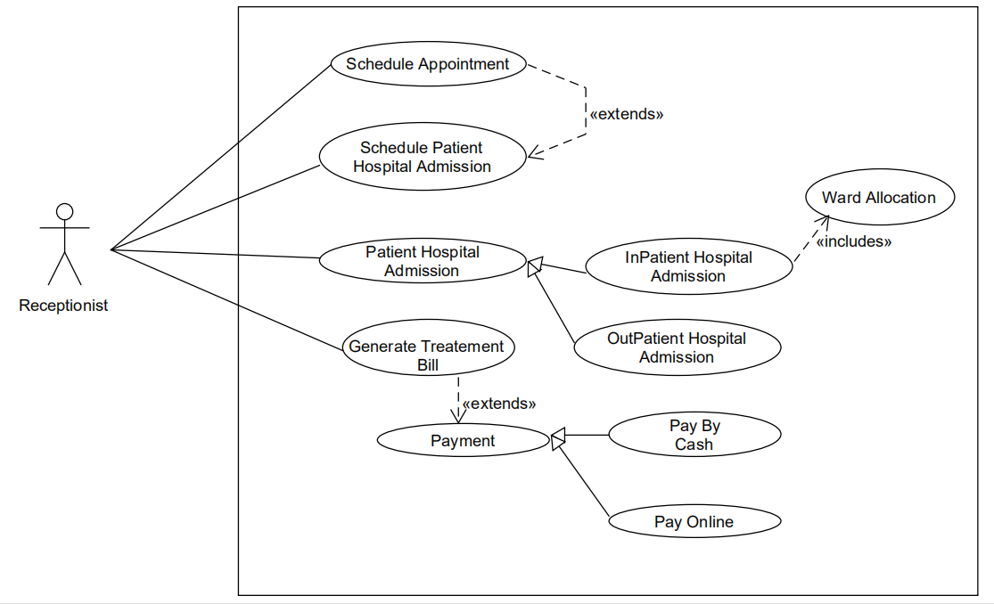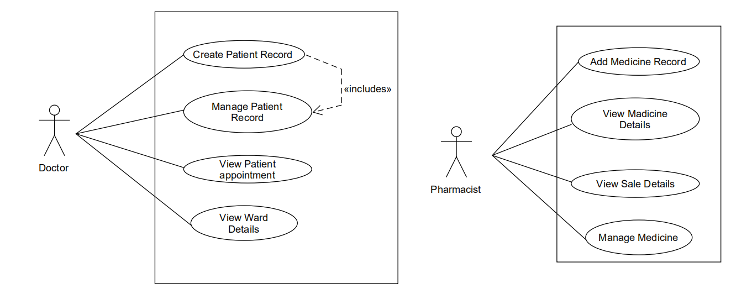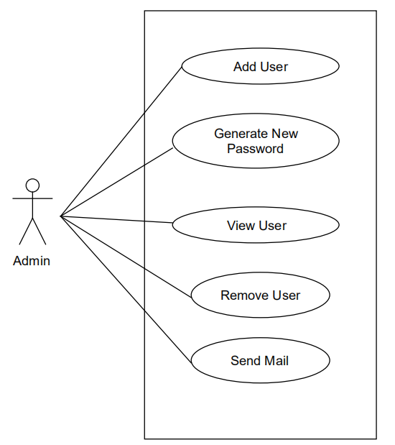

**Class Diagram**

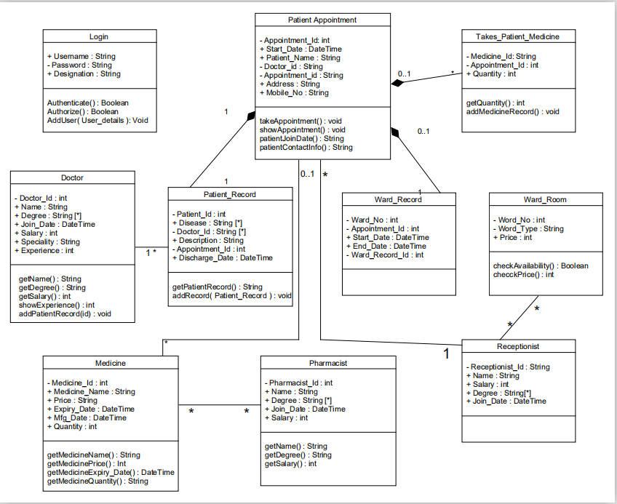

**Sequence Diagram**

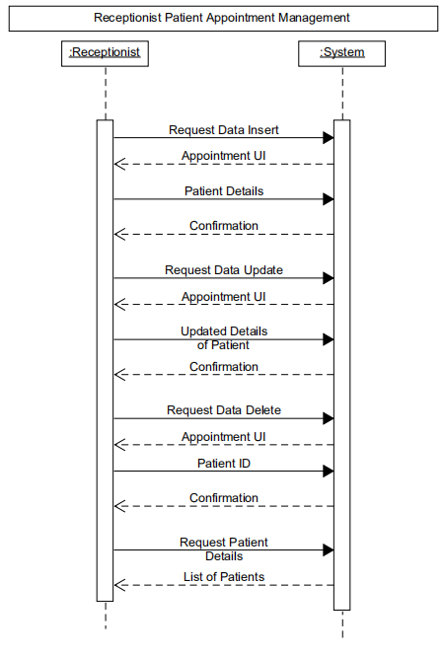

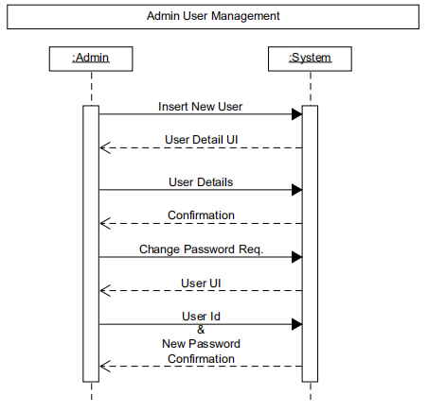

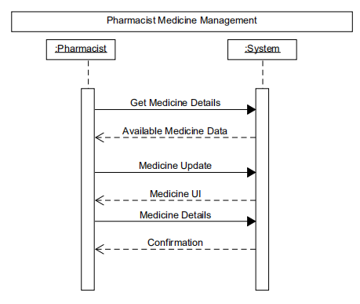

**Activity Diagram**

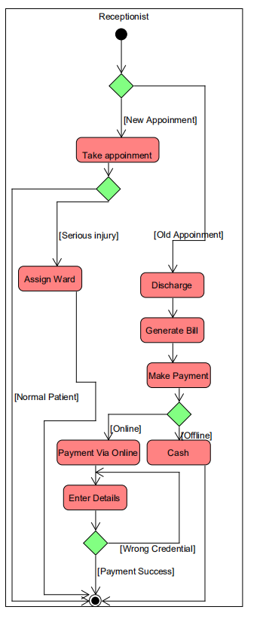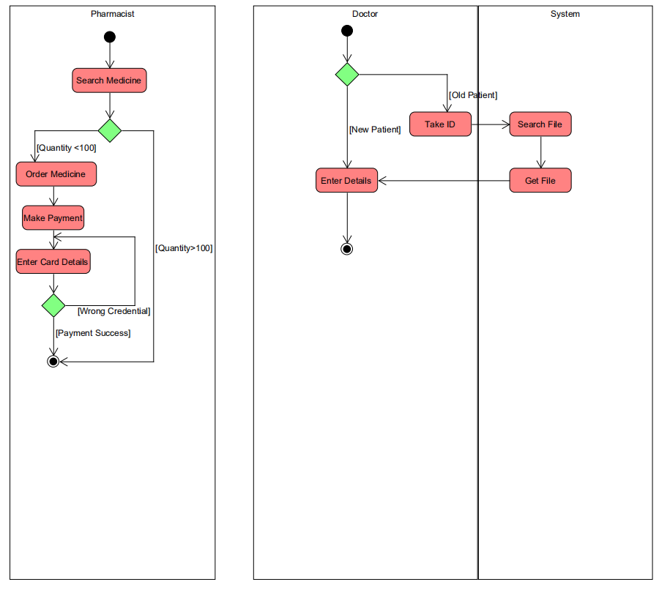

**State Diagram**

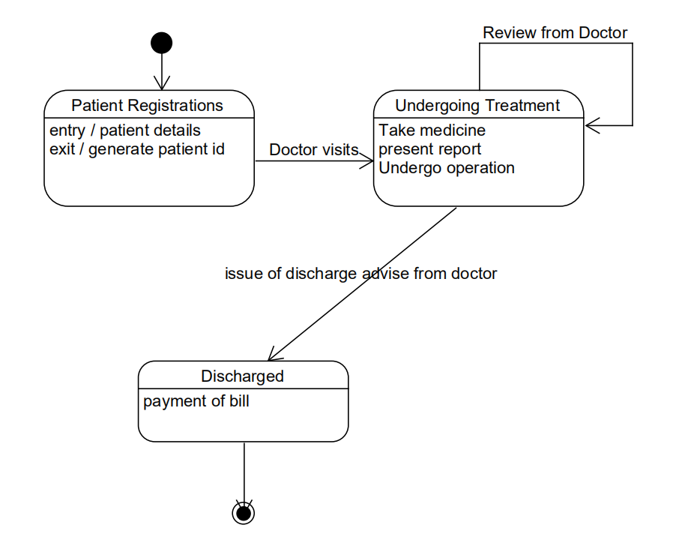

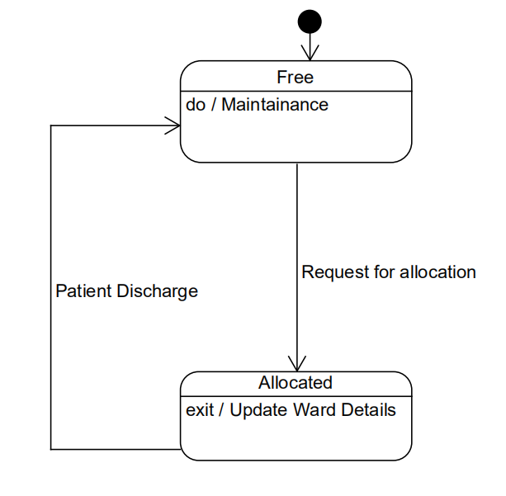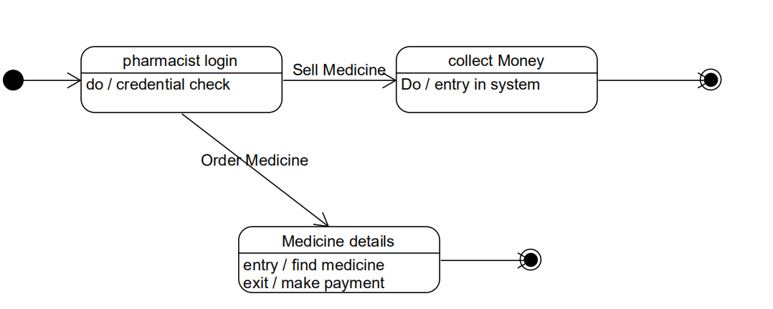

**Data Dictionary**

|  |  |  |  |  |  |  |  |  |
| --- | --- | --- | --- | --- | --- | --- | --- | --- |
| **PATIENT_APPOINMENT** | | | | | | | | |
| Sr. No. | Field Name | Data Type | Width | Required | Unique | PK/FK | Referenced Table | Description |
| 1. | Appoinment_date | Date | 10 | Yes | No |  |  |  |
| 2. | Start_date | Date | 10 | Yes | No |  |  |  |
| 3. | Patient_name | String | 30 | Yes | No |  |  |  |
| 4. | Doctor_id | Number | 10 | Yes | No | FK | doctor |  |
| 5. | Appointment_id | Number | 10 | Yes | Yes | PK |  |  |
| 6. | Address | String | 255 | Yes | No |  |  |  |
| 7. | Mobile No | number | 15 | Yes | No |  |  |  |

|  |  |  |  |  |  |  |  |  |
| --- | --- | --- | --- | --- | --- | --- | --- | --- |
| **MEDICINE** | | | | | | | | |
| Sr. No. | Field Name | Data Type | Width | Required | Unique | PK/FK | Referenced Table | Description |
| 1. | Medicine_name | String | 30 | Yes | Yes |  |  |  |
| 2. | Medicine_id | Number | 10 | Yes | No | PK |  |  |
| 3. | price | Number | 10 | Yes | No |  |  |  |
| 4. | Expiry__date | Date | 10 | Yes | No |  |  |  |
| 5. | Mfg_date | Date | 10 | Yes | No |  |  |  |
| 6. | Quantity | Number | 10 | Yes | No |  |  |  |

|  |  |  |  |  |  |  |  |  |
| --- | --- | --- | --- | --- | --- | --- | --- | --- |
| **PHARMACIST** | | | | | | | | |
| Sr. No. | Field Name | Data Type | Width | Required | Unique | PK/FK | Referenced Table | Description |
| 1. | Pharmacist_id | Number | 10 | Yes | Yes | PK |  |  |
| 2. | name | String | 30 | Yes | No |  |  |  |
| 3. | degree | String | 30 | Yes | No |  |  |  |
| 4. | Join_date | Date | 10 | Yes | No |  |  |  |
| 5. | salary | Number | 10 | Yes | No |  |  |  |

|  |  |  |  |  |  |  |  |  |
| --- | --- | --- | --- | --- | --- | --- | --- | --- |
| **DOCTOR** | | | | | | | | |
| Sr. No. | Field Name | Data Type | Width | Required | Unique | PK/FK | Referenced Table | Description |
| 1. | Doctor_id | Number | 10 | Yes | Yes | PK |  |  |
| 2. | name | String | 30 | Yes | No |  |  |  |
| 3. | degree | String | 30 | Yes | No |  |  |  |
| 4. | Join_date | Date | 10 | Yes | No |  |  |  |
| 5. | salary | Number | 10 | Yes | No |  |  |  |
| 6. | speciality | String | 30 | Yes | No |  |  |  |
| 7. | experiance | Number | 10 | Yes | No |  |  |  |

|  |  |  |  |  |  |  |  |  |
| --- | --- | --- | --- | --- | --- | --- | --- | --- |
| **PATIENT_RECORD** | | | | | | | | |
| Sr. No. | Field Name | Data Type | Width | Required | Unique | PK/FK | Referenced Table | Description |
| 1. | Patient_id | Number | 10 | Yes | Yes | PK |  |  |
| 2. | disease | String | 30 | Yes | No |  |  |  |
| 3. | Doctor_id | Number | 10 | Yes | No | FK | doctor |  |
| 4. | description | String | 30 | Yes | No |  |  |  |
| 5. | Appoinment_id | Number | 10 | Yes | No | FK | Patient_appoinement |  |
| 6. | Discharge_date | Date | 10 | Yes | No |  |  |  |

|  |  |  |  |  |  |  |  |  |
| --- | --- | --- | --- | --- | --- | --- | --- | --- |
| **WARD_RECORDS** | | | | | | | | |
| Sr. No. | Field Name | Data Type | Width | Required | Unique | PK/FK | Referenced Table | Description |
| 1. | Ward_no | Number | 10 | Yes | Yes | FK | Ward Room |  |
| 2. | Appinment_id | Number | 10 | Yes | No | FK | Patient_appoinement |  |
| 3. | Start_date | Date | 10 | Yes | No |  |  |  |
| 4. | End_date | Date | 10 | Yes | Yes |  |  |  |
| 5. | Ward_Record_Id | String | 20 | Yes | Yes | PK |  |  |

|  |  |  |  |  |  |  |  |  |
| --- | --- | --- | --- | --- | --- | --- | --- | --- |
| **LOGIN** | | | | | | | | |
| Sr. No. | Field Name | Data Type | Width | Required | Unique | PK/FK | Referenced Table | Description |
| 1. | Username | String | 30 | Yes | Yes | PK |  |  |
| 2. | Password | String | 30 | Yes | Yes |  |  |  |
| 3. | Designation | String | 30 | Yes | Yes |  |  |  |

|  |  |  |  |  |  |  |  |  |
| --- | --- | --- | --- | --- | --- | --- | --- | --- |
| **WARD_ROOM** | | | | | | | | |
| Sr. No. | Field Name | Data Type | Width | Required | Unique | PK/FK | Referenced Table | Description |
| 1. | Ward_no | Number | 10 | Yes | Yes | PK | Ward_records |  |
| 2. | Word_type | String | 30 | Yes | No |  |  |  |
| 3. | price | Number | 10 | Yes | No |  |  |  |

|  |  |  |  |  |  |  |  |  |
| --- | --- | --- | --- | --- | --- | --- | --- | --- |
| **Takes_Patient_Medicine** | | | | | | | | |
| Sr. No. | Field Name | Data Type | Width | Required | Unique | PK/FK | Referenced Table | Description |
| 1. | Medicine_id | Number | 10 | Yes | No | FK | medicine |  |
| 2. | Appoinement_id | Number | 10 | Yes | No | FK | Patient_appoinement |  |
| 3. | quantity | String | 10 | Yes | No |  |  |  |

|  |  |  |  |  |  |  |  |  |
| --- | --- | --- | --- | --- | --- | --- | --- | --- |
| **RECEPTIONIST** | | | | | | | | |
| Sr. No. | Field Name | Data Type | Width | Required | Unique | PK/FK | Referenced Table | Description |
| 1. | Receptionist_id | Number | 10 | Yes | No | PK |  |  |
| 2. | Name | String | 30 | Yes | No |  |  |  |
| 3. | Salary | Number | 10 | Yes | No |  |  |  |
| 4. | Join_date | Date | 10 | Yes | No |  |  |  |
| 5. | Degree | String | 30 | Yes | No |  |  |  |

* 1. **E-R Diagram**

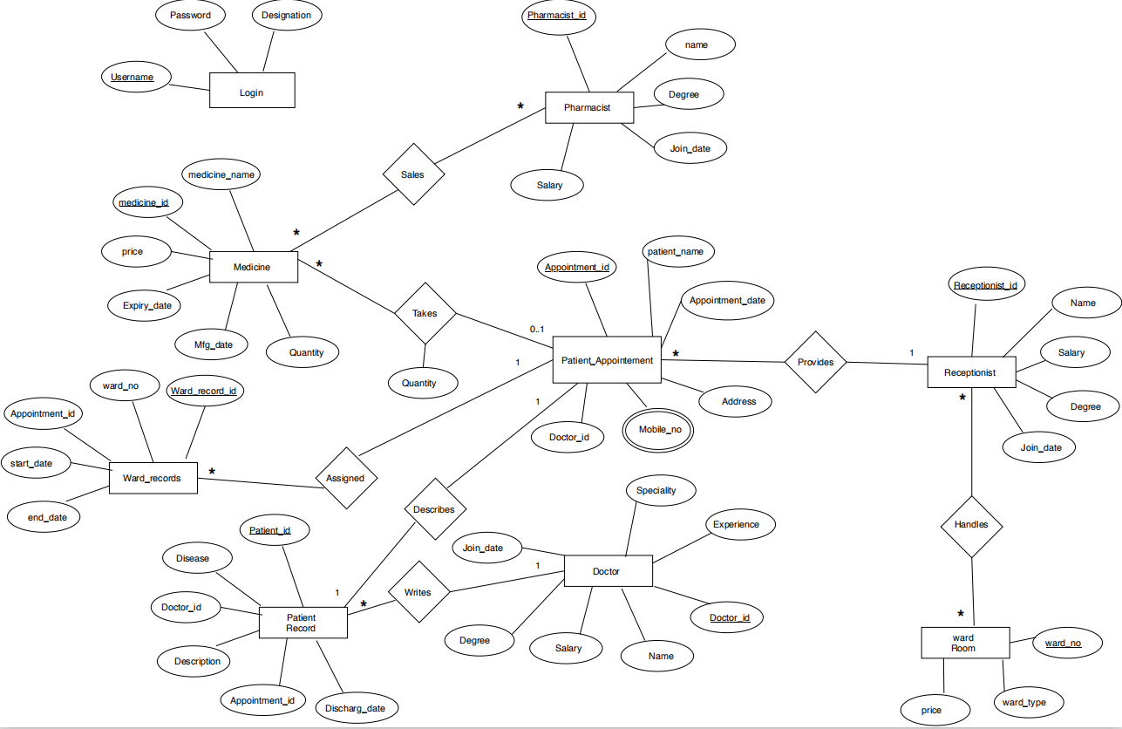



**5.1 Module Description**

* **Login Module**

This is home page of our window form application. According to credentials given by any user they can login into the system.

* **Registration Module**

If the administrator logs into the login page, then he gets permission to register a new user. No other user has permission for new registration.Admin can add Doctor, Receptionist, Pharmacist . If Admin add a pharmacist or doctor, then their degree, join date, specialty, salary, experience can be added to the database.

* **Pharmacist Module**

If pharmacists are logged in, they can see this module.No other user can see this module.If a new medicine comes, then the pharmacist can do its entry in the database and along with it, he can also add his quantity, price, manufacturing date and expiry date.The pharmacist can also view the list of all medicine.If the quantity of medicine is less than 10, then the pharmacist can see its list separately.

* **Receptionist Module**

If Receptionists are logged in, they can see this module.No other user can see this module. If a new patient comes, they can take an appointment from the receptionist along with that they can also add the appointment date, address, mobile number of the patient to the database.

* **Doctor Module**

If Doctor is logged in, they can see this module.No other user can see this module. The doctor can see the disease, discharge date and add to any patient's file.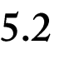

**Testing**

We have done Black box testing and also some validation testing like,

* checking For Sql injection Attack
  + - * We are using Entity Framework which internally using parameter query so, Sql injection can’t happen.
* checking Validation on Login as well as Registration
  + - * password and Confirm password must be same
      * Password must not have a first character digit
      * Authentication

**Screen Shot**

* Login page(Home Page)

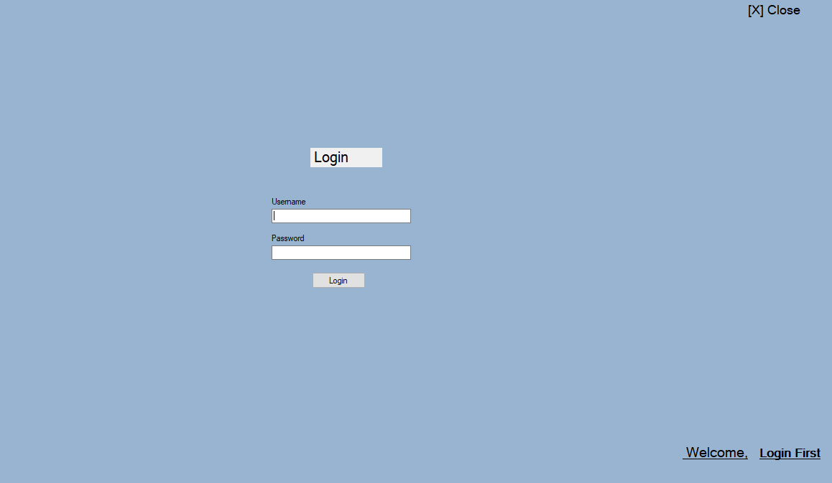

* After Admin login

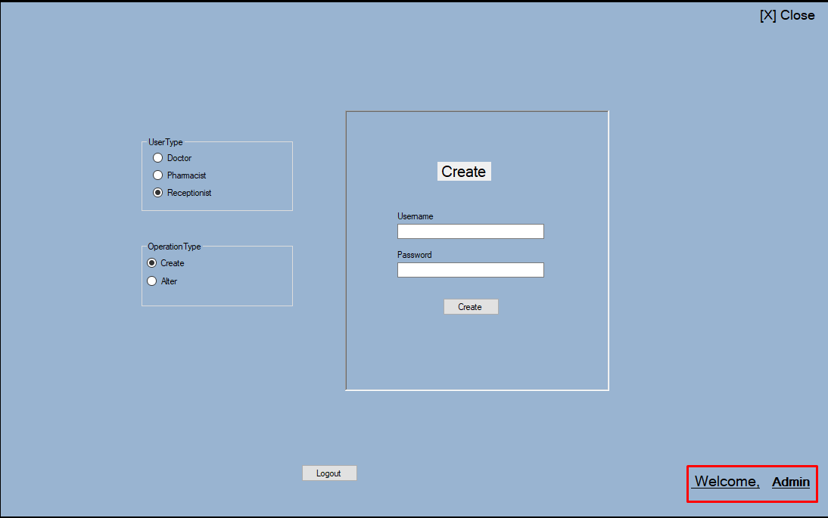

* Register for Doctor, Pharmacist, Receptionist

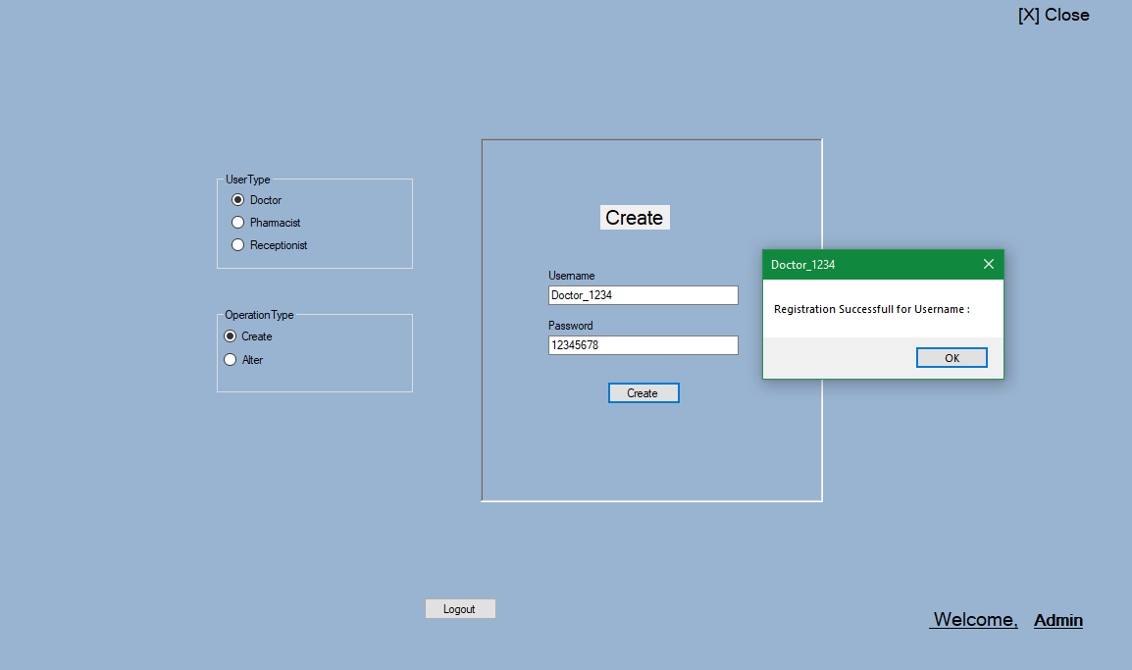

* Admin can Alter user data

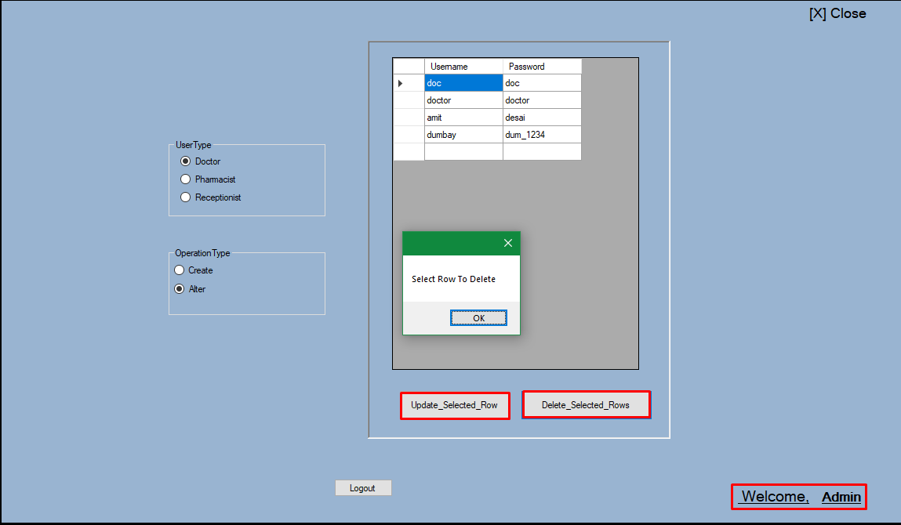

* After Doctor login, insert Patient Details

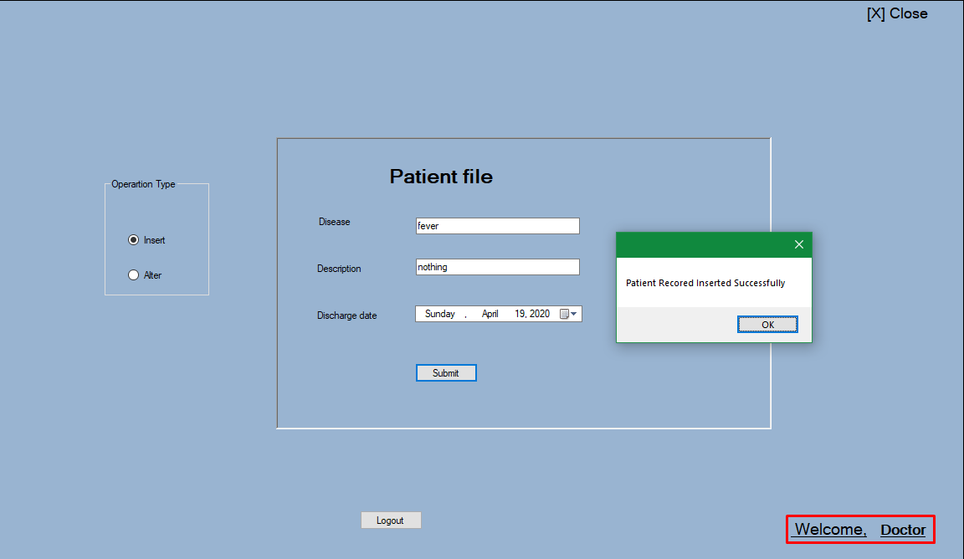

* Doctor can Alter Patient Data

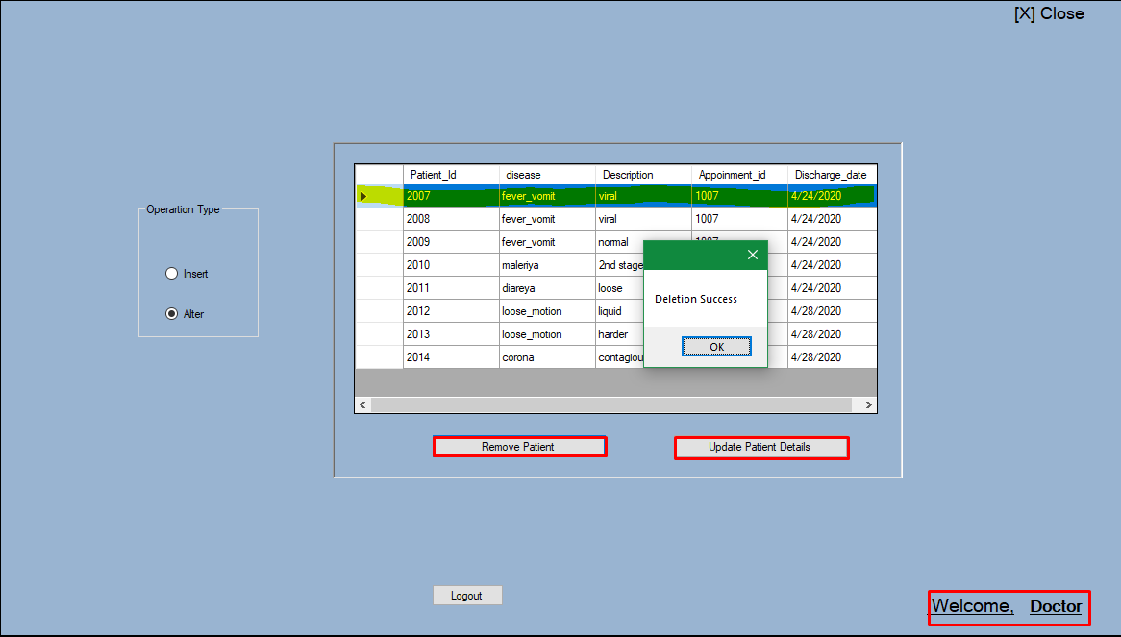

* After Pharmacist login, insert Medicine Details

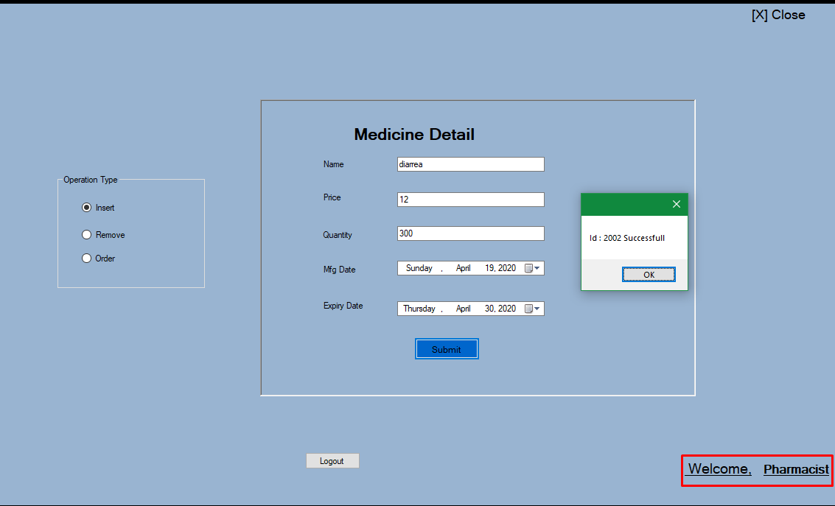

* Pharmacist can alter Medicine Details

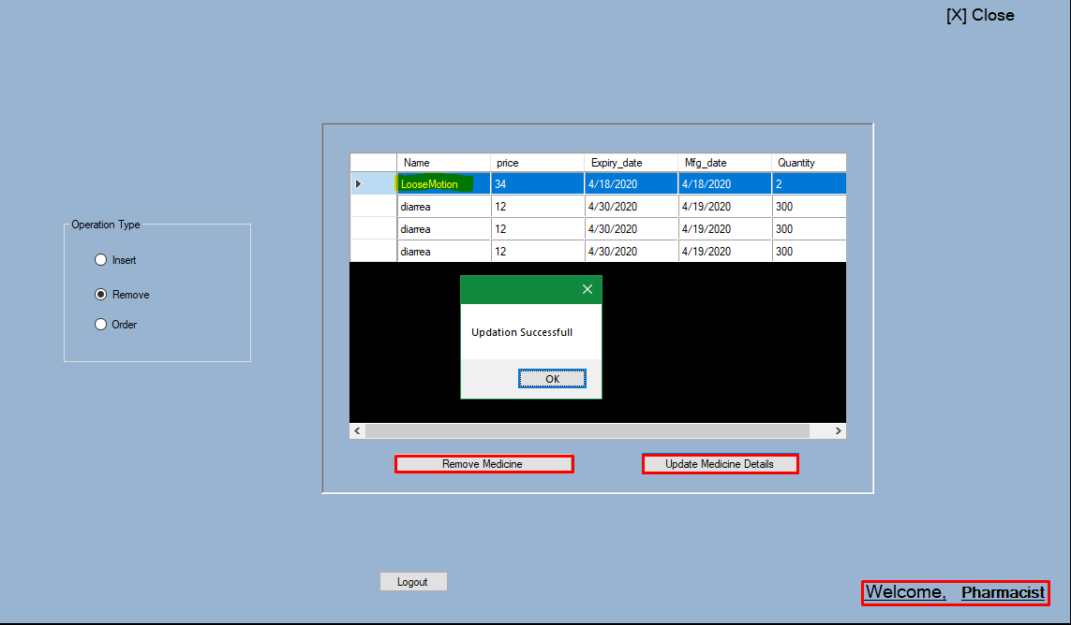

* After Receptionist login, insert Patient Appointment Details

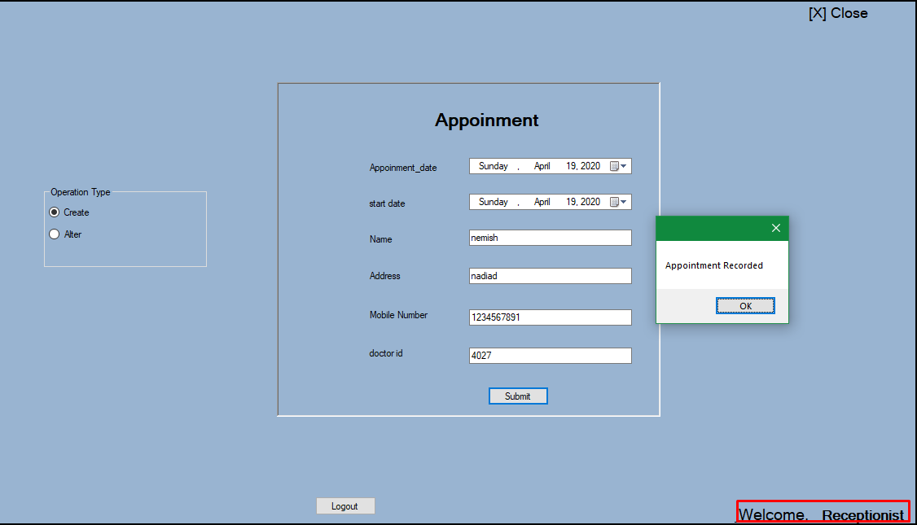

* Receptionist can alter Medicine Patient Appointment Details

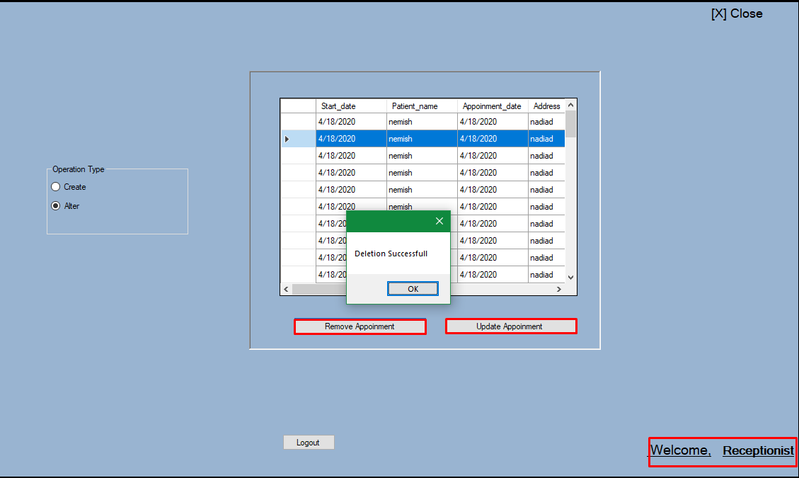

**Conclusion**

The Functionality implemented in the system was done after understanding all the system modules according to the requirements.

**Functionalities**

* Login
* Registration
* New Appointment
* Display Appointment Detail
* View Medicine Details
* Insert new Medicines
* Insert Patient’s Details.

**Limitation and Future Extension**

**Limitation**

* only​ one user per system

**Future Extension**

* SMS for Confirmation of Appointment.

**Bibliography**

* https://docs.microsoft.com
* https://stackoverflow.com